

IT510 Capstone Semester 2 Year 2026
  - AI vs Legacy Digital Forensics Tools – A comparative Efficacy analysis
  - Byte Harbor Butchers
  - Dave Sushames, Olivia Hey, Matt Baker, Sam Davies
  - Geoff Gordon
  - Whitireia and WelTec
Contents
Project Objective 2
Client background 2
Deliverables 2
Must haves 2
Nice to haves 2
Scope 3
Use of AI 3
Project Plan 4
Methodology 4
Kanban 4
NIST CTFF 5
Technologies 5
Project budget 9
Project Personnel 9
Client details including organisation 9
Group Members 10
Project Advisor 10
Communication plan 10
General Conflict of Interest statement 10
RACI assessment matrix 11
Project timeline and milestones 12
Project Risk Analysis 13
References 17
Appendices 18
Appendix A 18
Appendix B 19
The Parties 19
1. Effective Date 19
2. Undertakings 20
3. Copyright, Patents, Trade Marks and other Intellectual Property Rights 20
4. Confidential Information 20
5. Intellectual Property Rights 21
6. Signatures 21
Appendix C 22
Appendix D 22

Project Objective

Client background
The client for this project is Geoff Gordon who is a Network Administrator for WelTec and Whitireia, a local Polytechnic that is a subsidiary of Te Pūkenga – New Zealand’s Institute of Skills and Technology. Geoff offers technical support to staff, students and lecturers’ and is an on-site “fix-it” man for delivering technical solutions and helpful ideas (Whitireia & Weltec, n.d.).
The key problem Geoff would like solved is the comparison of traditional digital forensics tools to digital forensic tools that employ modern Large Language Models (LLMs) in the course of forensic artifact discovery for both Incident Response and Digital Forensics activities. Whether AI belongs in this domain or not will depend on whether AI-augmented tools use an unreasonable quantity of hardware resources and time to produce at best lesser quality and at worst erroneous forensic evidence or insights that are far below what is expected in fields that demand high standards of both ethical and evidentiary integrity.

Deliverables
The primary deliverable for this project is a research report that presents the working output and analysis of each test file processed using both traditional and AI-augmented forensic tools. The report with document the testing process, metrics used to assess each tool, and the resulting comparative findings and recommendation.
In addition to the written report, the project will include a video recording that demonstrates each tool in use against the test dataset. The video will serve as evidence that the described testing was performed, showing the tools being run, as well as their configuration and outputs. The combination of a written report and video evidence should ensure the project’s findings are transparent, reproducible, and verifiable by the client and project advisor.

Must haves
The main requirement of this project is proving that both traditional and AI-augmented forensic tools can be run on a single, locally hosted machine. They must use a shared test plan that both types of tools can be tested against under the same conditions. This baseline is important for a fair comparison, since hardware, dataset, and test conditions are variables that must be controlled for a valid experiment to be run.
The final report must include a discussion of which stages of the forensic process (evidence acquisition, memory analysis, file carving, metadata extraction) are most affected by the introduction of AI, and much clearly state whether the resource cost of AI-augmented tools is justified by improvements in accuracy, speed, or usability.

Nice to haves
An investigation into the ethicality and risk of data leakage with AI-based forensic tools is not strictly required for this project but is considered a valuable addition if time allows. Other optional additions include testing on larger models, which would require additional equipment such as higher-end GPUs with more memory. Therefore, testing on a dual-GPU setup is considered a stretch goal rather than a requirement.
It is also useful to establish whether output of a larger model is worth the extra resources it requires, compared to a smaller model. This is due to the fact that accuracy is a very important factor in the production of a forensics report. Determining whether investing more resources produces a higher quality or more usable output would be valuable to the project’s conclusions. Additional stretch goals include developing scripts or an environment to automate parts of the testing process, and monitoring network traffic during testing to confirm that data is not leaving the network.

Scope
Tools that can be run in the Kali Linux environment for the intended uses of performing digital forensics against publicly available datasets are within the scope of this project. Forensic testing and analysis will be performed on OS and mobile-based datasets. As forensics expands a wide variety of activities such as data-carving, memory forensics and network forensics, these will all be considered in-scope for this project as we are looking to test these tools against a variety of different datasets to display their strengths and weaknesses. The testing of legacy forensics tools and tools that are aided by artificial intelligence are in scope as we are looking to compare the two types of tools. The analysis and documentation of said testing is also within scope.
Incident Response (IR) and Digital Forensics (DF) are fields which are closely related, they both involve the discovery and analysis of digital artifacts, however, they tend to prize different properties of tools. Digital Forensics values the integrity and quality of evidence for use in criminal investigations. If chains of custody and audit trails are not producible by or based on the output of LLM-augmented tools, then the use of that tool can potentially compromise a criminal case. Alternatively, Incident Response values the swiftness required to detect, analyse, diagnose, and quarantine during an ongoing security incident, and particularly to gather and consolidate digital evidence during this time to assist incident recovery by identifying attack vectors, exploits, indicators of compromise, and attacker identity. For this project, both Incident Response and Digital Forensics are in scope, but will likely require separate test cases to reflect the quality of their preferred metrics respectively.
The development of our own tools for forensics purposes isn’t considered within the scope of the project; we will be using publicly available ones instead. While a brief discussion on ethics and risks of data leakages is considered a nice to have inclusion, a full investigation into them is considered to be outside the scope of this project. Cloud-based tools are also out of scope; this is because the machine we will be working on is a locally hosted machine on a local network.
We are not interested in our model’s abilities to generate reports, or come to conclusions based on our evidence, our investigation into the efficacy of these tools is in their empirical capacity. Essentially their usefulness to an examiner as opposed to an investigator. An examiner in Digital Forensics employs specialized forensics tools to collect evidence from a range of digital sources and mediums, in criminal investigations, the evidence retrieved by forensic examiners is used in a court of law as a foundation for legal proceedings. (PECB, n.d.). A forensics investigator, who could also be the examiner, consolidates this evidence into the report that is displayed in court, they produce the big picture and connections between forensic artifacts, they are more concerned with how the evidence fits together and generates criminal liability.

Use of AI (LLMs)
The first distinction that is important to define is the differences in technologies that can be categorized under the superset of “AI”.
Figure 1 – Relationship between AI technologies
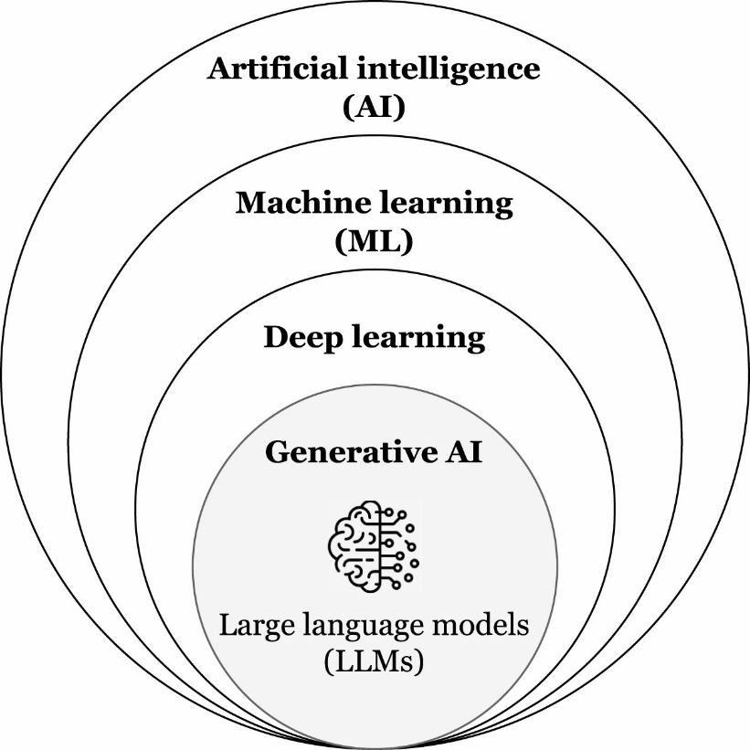
(Maxim Chernyshev, Baig, Naeem Syed, Robin Doss, & Shore, 2026)
Figure 1 represents the consecutive subsets of AI technologies as they have evolved, artificial intelligence simply describes “computational systems designed to perform tasks that typically require human intelligence – such as reasoning, learning, and problem-solving.” (Maxim Chernyshev, Baig, Naeem Syed, Robin Doss, & Shore, 2026).
Machine learning furthers this effort by training machines to recognize patterns in the pursuit of specific tasks. In DFIR (Digital Forensics and Incident Response), this could be used to automatically detect forensically relevant artifacts within the large quantities of data that are present on hard drive disk images, memory dumps, and mobile phones, such as recognizing indicators of malware based on large quantities of training data.
Deep learning is a further advancement designed to simulate the neural networks in a human brain, this technology is produced by training the system on vast amounts of data to identify patterns to produce predictions by incrementally reducing the difference between “predicted outputs and true outputs” (ISO, n.d.). This could be something like identifying the difference between Kea’s and Kereru’s for 10,000 cycles, this incremental differentiation enforces a strong predictive capacity to the point where the system can identify a Kereru with a high degree of accuracy.
Generative AI is a subset of deep learning, now the AI is capable of drawing or describing a Kereru by further learning the “underlying probability distributions of their training data to produce new instances resembling the original corpus” (Maxim Chernyshev, Baig, Naeem Syed, Robin Doss, & Shore, 2026).
Large language models (LLMs)
There are two fundamental principles under which we consider a DFIR tool "augmented by AI":
The Automation/optimization of existing DFIR tool/s by advanced machine learning algorithms and generative AI:
-Unfold
-Unearth
-Mulder
An entirely new process of evidence discovery; employing the capacity of an AI model to uncover DFIR artifacts:
-PassGPT

This requires interfacing locally hosted AI models on Ollama or LMStudio via the LiteLLM proxy to tools that are designed to leverage this ability to specifically detect forensically relevant digital artifacts within our datasets

Project Plan

Methodology

Kanban
Kanban is an Agile Methodology which means that it is an approach that divides work into phases, emphasising continuous delivery and improvement and allows for teams to work simultaneously allowing for greater amounts of work to be delivered in a shorter time than traditional development methodologies such as the Waterfall, Methodology which requires a team to hand off work after the team has completed their part of the project. We have selected Kanban because it is one of the key Project Methodologies used in the current real-world workplaces (Radigan, n.d.). Kanban is a visual workflow management method that will allow us to better visualize the workload and optimise it according to demand. Kanban works best for us because it is familiar to us as we have used it in previous classes and can be integrated seamlessly into our project it is also a suitable methodology for our topic because it is a research-oriented project. Milestones...
Scrum is another development methodology that leverages feedback loops from frequent team meetings and workflows that work together in these feedback loops to get feedback and achieve work completion. Scrum as a development methodology requires a strong degree of trust and commitment from all members of the scrum team, this means that members must be diligent in their work flows and complete work according to schedule in order to ensure that the iterative process is flowing continuously, this means that in order for work to be completed work needs to be completed so that it can be iterated on, the faster this iterative process is completed the faster the project can be completed. How this works is that scrum dictates that there are daily meetings in order for completed work to be evaluated and for new work to be assigned based on the status of completed or in process work, this means that members of the team can be held accountable for work and adjusted for daily in the timeline based on the proposed completion date of work. Scrum works on three pillars, these being transparency, inspection, and adaptation, and finally a bases of trust between leadership and workers. These values ensure that work that is being completed is competent and timely.
The project management methodology that we have selected is kanban because we felt that the scrum methodology fit better towards a software development project than it did to a research project which is what our project is oriented towards, we also felt that the daily meetings required by scrum to assess workflows would not suite our team members because of the different requirements we each have from outside life as well as school commitments which dictate that our schedules are different to each other and may conflict with the daily meetings arrangement and as such we thought that despite both being Agile development methodologies we felt Kanban with one mandated weekly meeting would better suit our requirements.

NIST CTFF
The Testing Methodology that we have selected is the Computer Forensic Tool Testing (CFTT) process by National Institute of Standards and Technology (NIST), which is a functionality driven testing methodology (NIST, 2026). We believe it reflects the requirements of our project because of the nature of the research driven outcomes. The adapted CFTT process is as follows: Acquire tool to be tested, Review tool documentation, select relevant test cases depending on features supported by tool, develop test strategy, execute tests, produce test report, Team reviews test report, Client reviews test report, Add findings to final report. Using this testing process, we believe that we can achieve the outcomes required of our project as it is a testing process specific to tool testing.

Technologies
This section of the report will outline the different technologies that will be used during our project. The Technologies that will be used are Kali, which is a Linux distribution, LM studio and Ollama, Git Hub, Discord and the various tools that we have selected for evaluation.

Kali
Kali is an open-source, Debian based Linux Distribution which allows users to perform advanced penetration testing and security auditing. Kali is specifically tailored to the needs of experienced penetration testers and therefore is the perfect operating system for us to be using for our project. The Version of Kali Linux we will be using is the Kali rolling version (Kali GNU Linux Rolling 2026.3) which is the most updated version pulled from kali-dev, which is the Debian testing area for new kali updates.

LM Studio & Ollama
LM Studio and Ollama are platform’s for hosting Large Language Model’s (LLMs) on local machines (Computers/PCs). LLMs are advanced AI systems built on neural networks and algorithms designed to process information sent to it and generate responses in human legible plain text, some examples of LLMs are ChatGPT or Claude which are mainstay powerhouse LLMs that process millions of tokens each day, a token essentially being the cost to generating a response, this cost is presented as a token but is actually the processing power required to generate the response and can be calculated as such. Large corporations such as OpenAI or Anthropic use these systems to answer prompts given to them by online users, which potentially poses a risk to security as data would need to be sent outside of the local computer to the data centres which unnecessarily exposes the information that you have provided it to an outside source. Given that this is a project to assess security tools and AI functionality we have decided to mitigate this risk by running the entire process on our own locally hosted machine using LM Studio and Ollama because they provide the functionality to take advantage of systems that we already have (such as graphics cards) and put them to use in creating a system that will run our own locally hosted models, therefor completely mitigating the risk of data leakage. How LM Studio and Ollama do this is by taking advantage of the processing power on the computer and leveraging it to process tokens and generate output for the end user (us), this however requires a strong graphics card of which one has been provided by the school and one has been provided by one of our team members. LM studio and Ollama will be running on the latest available versions however for documentation’s sake LM studio will be running version LM Studio 0.4.21 (Build 2) and Ollama will be running on Ollama 0.32.9.

GitHub
Our group will be using GitHub repository in order to collate our work, Git Hub is a program that allows us to work from a single repository /directory which makes it easy for us to keep a single documented project file which can then be submitted as our work at the end of the project, this also provides us with a clear history of changes and can provide a timeline for when work was completed in order to be presented once the project has been completed.
GitHub link: https://github.com/DavidSushames/BHB-Capstone

Discord
The team will communicate primarily using Discord. Discord is a program that allows users to communicate both orally and over text/images through servers provided by Discord itself, this effectively enables us to use this space as constant meeting room that we can join in and out of according to our day-to-day requirements. This was chosen because discord is our preferred communication device that we are well comfortable with as we have all used it in the past and will be used to host our team meetings.

Tools
The following is a list of tools and their descriptions that either do or do not work however are the tools that we intend on using in our analysis should they work. The tools listed below are either AI augmented tools or tools that are not AI augmented.

HashCat
HashCat is the world's fastest and most advanced password recovery utility, supporting five unique modes of attack for over 300 highly optimized hashing algorithms. HashCat is a program/script that cracks passwords, or in other words this program works using the GPU to run different algorithms to solve passwords thus “cracking” them. This is not an AI tool and therefore does not require the use of LLMs.
The version being used is: HashCat v7.1.2+ds1-4
https://github.com/hashcat/hashcat

John The Ripper
John the ripper is another password cracking program, with the intention of this program to be similar of HashCat in the sense that it shares the same outcomes from the same goals. This is not an AI tool and therefore does not require the use of LLMs.
The version being used is: John the Ripper v1.9.0-jumbo-1+bleeding-aec1328d6c
https://github.com/openwall/john

CyberChef
CyberChef is a simple, intuitive web app for carrying out all manner of "cyber" operations within a web browser. These operations include simple encoding like XOR and Base64, more complex encryption like AES, DES and Blowfish, creating binary and hex dumps, compression and decompression of data, calculating hashes and checksums, IPv6 and X.509 parsing, changing character encodings, and much more. The tool is designed to enable both technical and non-technical analysts to manipulate data in complex ways without having to deal with complex tools or algorithms. This is not an AI tool and therefore does not require the use of LLMs.
The version being used is: CyberChef v11.3.0 - 2026-07-24
https://github.com/gchq/CyberChef

Volatility
Volatility is a volatile memory analysis (RAM) tool that allows us to look at processes held inside of computers at the time the “screenshot” of volatile memory is taken, i.e. an image of the machines processes is taken and saved to be processed by Volatility. We have chosen this tool due to our familiarity with it also due to the fact that it is a memory forensics tool that can be compared to others that complete similar objectives. This is not an AI tool and therefore does not require the use of LLMs.
The version being used is: Volatility 3 Framework v2.28.2
https://github.com/volatilityfoundation/volatility3

ExifTool
Exiftool is a platform independent command line application for reading writing and editing meta information in a wide variety of files, this primarily can be used for editing metadata. This is not an AI tool and therefor does not require the use of LLMs.
The version being used is: ExifTool v13.55
https://exiftool.org/

Foremost
Foremost is a tool that is used as a digital forensic program to recover lost files based on their header’s footers and internal data structures, foremost works on image files, such as those generated by dd, safe back, encase, etc or directly onto a drive. This is not an AI tool and therefor does not require the use of LLMs.
The version being used is foremost version v1.5.7
https://www.kali.org/tools/foremost/

Sherloq
Sherloq is a open source digital image forensic toolset which enables users to engage with images and see if images have been edited or not, though it is not autonomous it is designed to be a companion in experimenting with various algorithms found in the latest research papers and workshops, meaning this tool is more of an expression of self than a project designed to fix a problem, meaning that this tool is potentially incomplete and therefor should be used with caution and an open mind in terms of its functionality. This tool is not an AI tool and therefor does not require the use of LLMs.
The version being used is: Sherloq v0.94F
https://github.com/GuidoBartoli/sherloq

TruFor
Trufor is a tool based on a forensic framework that can be applied to a large variety of image manipulation methods, from classic Cheap fakes to more recent manipulations based on deep learning. In short, this program works to provide statistical information regarding potentially manipulated images as it provides an integrity score afterwards that can help inform the users decisions on whether or not the image has been manipulated. I do not know if this tool uses AI or not
The version being used is: TruFor commit ae54475df6f41a491d7615100feb19263dec13f7, Date: Thu May 29 09:46:01 2025 +0200
https://github.com/grip-unina/TruFor/tree/main

WireShark
Wireshark is a network monitoring tool that allows users to see what’s happening on their network at a microscopic level, this meaning that it enables users to see all the incoming and outgoing traffic to and from their computer as well as the network they are connected to, this means that packets can be inspected for malicious activity and any other nefarious work travelling through their network. This application does require the use of AI.
The version being run is: WireShark v4.6.6
https://www.wireshark.org/about.html

PassLLM
PassLLM is essentially a Large Language Model which uses Personally Identifiable Information (PII) – such as names, birthdays, phone numbers, emails and previous passwords to predict passwords that targets are likely to use. The LLM uses this information and guesses passwords based on the information it has and supposedly outperforms other models by 15% to 45% in most scenarios meaning that this is a potentially capable system. Obviously due to the nature of LLMs this machine uses AI to achieve its outcomes.
The version being used is: PassLLM v1.3.0
https://github.com/Tzohar/PassLLM

Unearth
Unearth is digital forensics investigating platform designed to help investigators uncover hidden or deleted information from digital systems, it combines data recovery techniques with intelligent content analysis in a single environment. The platform can recover deleted files from modern file systems and analyse recovered data and assist investigators in understanding what happened in a system. This system includes AI based tools.
The version being used is: Unearth version v1.0.0
https://github.com/bhargavgajare1479/Unearth

Valhuntir
Valhuntir is an AI augmented but human driven program that turns a single incident response analyst into the manager of an agentic AI incident response team. A host of MCP tools allows for the AI to quickly ingest, process and analyse massive amounts of digital forensics artifacts while keeping the human in control of the investigation and decision-making process. This means that despite being an AI tool it allows for the human in control to drive the process and steer it into the deliverables the human is seeking to achieve. The AI must be hosted on your own system or on the same network and therefor will take advantage of our system that we have setup. This obviously uses AI tools
The version being used is: Valhuntir v0.6.1
https://github.com/AppliedIR/Valhuntir

Unfold
Unfold is a tool that functions by using the volatility3 script in order to run Disk analysis digital forensics, it does this by running a script that invokes a python shell for volatility3 from where you can input the commands to receive the desired outcomes, this application is allegedly packaged with AI functionality however it seems that this is packaged in a manner that requires it to be outsourced to OpenAI or DeepSeek which leads us to believe that it is not the most secure tool. This tool has AI functionality but for the most part relies on Volatility3 for its capabilities and therefor is reflective of that tool.
The version being used is: Unfold v3
https://github.com/arazazi/UNFOLD

Autopsy
autopsy is the premier open-source forensics platform, which is fast, easy to use, and capable of analysing all types of mobile devices and digital media. Its plugin architecture enables extensibility from community developed or custom-built modules. Autopsy evolves to meet the needs of hundreds of thousands of professionals in law enforcement, national security, litigation support and corporate investigation. This tool does not use AI:
The version being used is: Autopsy v2.24
https://www.autopsy.com/

Project budget
Our project should not include any costs whatsoever to the client or the team members because all equipment used are either provided by team members, client or Whitireia and Weltec, and any software used should be free. The equipment submitted for the project will be returned to the relative owners after the project is completed.

Project Personnel

Client details including organisation
Geoff Gordon is a staff member of WelTec, he provides technical networking expertise in the context of the tertiary environment. He has familiarity, curiosity and deep interest in AI models and their behaviour, as well as their associated hardware/platforms. He is interested in whether AI is has a place in the field of digital forensics.
Geoff has been the client on multiple previous capstone IT projects with a focus on AI. One example is an AI chatbot for IT support at the school.

Group Members
Table 1 - Group members
Name | Role | Main duties
Matt Baker | Digital Forensics Technician | Installation, configuration, research, troubleshooting, and implementation of software/tools/operating systems required to support our investigation. Integration of AI into our forensics tools. Designing testing environments and performing forensic activities with legacy and AI based forensics tools, recording the results under a reliable doctrine.
Sam Davies | Digital Forensics Technician | Maintain availability of the physical PC used to power the AI models. Ensures that processing power is consistent before testing via benchmark. Employing forensics tools during tests and communicating lessons from previous similar projects.
Olivia Hey | Digital Forensics Technician | Documentation, organization of evidence, forensic disk images and datasets, research material as well as partaking in the testing itself. Keeping track of testing documentation, organizing results for testing under diverse criteria.
Dave Sushames | Project Manager | Organises meetings with the client/advisor, consolidates individual log hours into the group hours log, manages the git repository, contributes to collaborative documents and conducts research. Ensures we are following the chosen methodology.

Project Advisor
The project advisor for this project is Clement Swarnappa.

Communication plan
Table 2 - Communications plan table
Name | Email address | Primary Method of Contact
Client: Geoff Gordon | Geoff.Gordon@whitireia.ac.nz 0211576328 | Email
Project advisor: Clement Swarnappa | Clement.Sudhakar@weltec.ac.nz | Email
Group project manager: Dave Sushames | david.sushames@gmail.com | Discord
Group member: Olivia Hey | Olivia-hey.hey01 | Discord
Group member: Matt Baker | mattwillbaker1@gmail.com | Discord
Group member: Sam Davies | Samueldavies0220@gmail.com | Discord

General Conflict of Interest statement
As our client Geoff Gordon is a member of the WelTec staff, his employment relationship with the institution running the capstone course creates a potential conflict of interest. In addition, the team’s familiarity with Geoff could create a personal or professional relationship that could affect the objectivity of interactions between client and students.

RACI assessment matrix
This matrix divulges the relative responsibility the stakeholders of this project possess with regards to each task. R – Responsible A – Accountable C – Consulted I – Informed
Table 3 - RACI Assessment Matrix
Tasks | Geoff Gordon (Client) | Clement Swarnappa (Advisor) | Dave Sushames (PM) | Matt Baker | Olivia Hey | Sam Davies
Installation, management of physical hardware. | R | I | C | C | C | R
Installation/configuration of operating systems and software (LMStudio, forensic tools such as volatility/exiftools/foremost) | C | I | I | R | A | A
Acquisition of forensic datasets/disk images for analysis | I | I | C | C | R | C
AI integration with digital forensics tools | C | I | C | R | C | C
Creation or adaption of a process (CFTT) and metrics with which to objectively assess the efficacy of two or more tools. | C | C | R | A | A | A
Documentation and measuring of results of testing. | C | C | C | R | R | R
Testing in multiple evidence environments (mobile/desktop) on multiple types of target data (credentials, confidential information, intrusion indicators, suspicious processes/media) | I | I | C | R | R | C
Design a consistent test environment, ensuring all variables are the same and that available processing power is consistent before testing. | I | I | C | R | R | R

Project timeline and milestones
Table 4 - Main milestones and deliverables dates
Requirement | Specific date OR academic week of semester
Proposal due (academic) | Week 4
Mid project proposal thing
Client Demo (client) | Week 14
Final Panel (academic) | Week 16 or 17
Need more of these timeline things

Project Risk Analysis
Table 5 - Risk Assessment matrix
 | Severity
Likelihood | 1 | 2 | 3 | 4 | 5
5 |  | R04 Formatting inconsistencies.
4 | R15 Version control conflicts. |  | R02 Team member becomes unavailable. | R01 Missed deadlines.
3 |  | R12 Internet outage. | R05 Misunderstood requirements.  R06 Software difficulties.
2 |  | R14 Power outage. | R09 Client becomes unavailable.  R10 Advisor becomes unavailable.  R11 Tech/Vendor becomes unavailable. | R07 Hardware stolen.  R08 Data/File loss/corruption. | R03 Academic integrity violation.
1 |  |  |  |  | R13 Natural disaster or pandemic.

Table 6 - Risk Mitigation plan
Risk | Mitigation
R01 Missed deadlines | Have regular team meetings to check everyone’s progress, see what’s lacking.  Break work into set milestones with internal deadlines.
R02 Team member becomes unavailable | Ensure multiple team members can do the same tasks. Keep documentation current and have required tasks be visible for the whole team.
R03 Academic integrity violation | Clearly attribute any external code, sources, and AI tool use. Individual contributions tracked via commit history so authorship can be verified.
R04 Formatting inconsistencies | Agree on a style/template before writing begins. Do a formatting pass before each submission.
R05 Misunderstood requirements | Confirm requirements in writing after each client/advisor meeting. Review minutes with the team.
R06 Software difficulties | Research/experiment with new tools early, before committing to them. Choose tools with good documentation and/or team familiarity.
R07 Hardware stolen | Keep PC in locked network room, in an inconspicuous location. Label components with owner’s name. Have photo proof of ownership.
R08 Data/File loss/corruption | Regular backups should be done in multiple locations. Regularly commit/push to Git.
R09 Client becomes unavailable | Get requirements and scope signed off early, so project can continue even without ongoing client input.
R10 Advisor becomes unavailable | Keep written records of advisor meetings so the project isn’t reliant on any single conversation.
R11 Tech/Vendor becomes unavailable | Use established, actively maintained tools where possible. Have backup options in case one tool goes down.
R12 Internet outage | Have a backup communication method (phone/text) for if discord/zoom is unreachable.
R13 Natural disaster or pandemic | Make sure the majority of work can be completed from home and doesn’t require onsite presence.
R14 Power outage | Save work frequently. Keep a laptop with files synched to it so that work can continue if power goes out.
R15 Version control conflicts | Everyone works in separate files, then copies the whole section into the main document once done. Communicate before editing the main document.

Table 7 - Risk Contingency plan
Risk | Contingency actions
R01 Missed deadlines | Urgent team meeting to reprioritise, meet with client to discuss cutting scope. Inform advisor if final deadline is at risk.
R02 Team member becomes unavailable | Redistribute missing team member’s tasks to the rest of the team. Inform advisor if unavailability is for an extended period of time. Possibly request scope adjustment.
R03 Academic integrity violation | Notify advisor/coordinator. Team member responsible admits fault.
R04 Formatting inconsistencies | Do a pass before each submission to ensure consistent formatting.
R05 Misunderstood requirements | Book urgent meeting with client/advisor for clarification. Revise documentation for requirements.
R06 Software difficulties | Ask advisor for guidance. If software is too difficult to work with, fall back to an easier alternative tool.
R07 Hardware stolen | Report to WelTec and police. Contact client, advisor, and possibly coordinator for further steps.
R08 Data/File loss/corruption | Notify team urgently, attempt to recover from most recent Git commit. Inform project advisor if loss is significant.
R09 Client becomes unavailable | Continue work according to last signed off requirements. Inform advisor/coordinator.
R10 Advisor becomes unavailable | Escalate to course coordinator for advice. Continue work according to last agreed requirements in the meantime.
R11 Tech/Vendor becomes unavailable | Switch to an alternative tool or last available open-source version. Inform client/advisor if functionality impact is significant.
R12 Internet outage | Fall back to phone/text to stay coordinated. Work offline, or tether/hotspot using mobile data to stay online.
R13 Natural disaster or pandemic | Shift all work to fully remote. Hold all meetings online instead of in person.
R14 Power outage | Switch to laptop while battery lasts, continue work where possible. Sync changes once power restored.
R15 Version control conflicts | Resolve conflict with Git’s merge tools. Affected team members should discuss which lines to keep.

References
Maxim Chernyshev, Baig, Z., Naeem Syed, Robin Doss, & Shore, M. (2026, October 26). Large language models in digital forensics: capabilities, challenges and future directions. Retrieved from https://www.sciencedirect.com/science/article/pii/S2666281725001830#fig0010
NIST. (2026, May 1). Computer Forensics Tool Testing Program (CFTT). Retrieved from NIST: https://www.nist.gov/itl/csd/secure-systems-and-applications/computer-forensics-tool-testing-program-cftt/cftt-general-0
PECB. (n.d.). Certified Digital Forensics Examiner – Training Course. Retrieved from PECB: https://pecb.com/en/education-and-certification-for-individuals/certified-digital-forensics-examiner#first
Radigan, D. (n.d.). What is Kanban in project management? Breaking down the methodology. Retrieved from Atlassian: https://www.atlassian.com/agile/kanban
Whitireia & Weltec. (n.d.). Our Staff. Retrieved from whitireiaweltec: https://www.whitireiaweltec.ac.nz/about-us/staff-profiles

https://www.scrum.org/learning-series/what-is-scrum/
https://www.atlassian.com/agile
https://lmstudio.ai/
https://ollama.com/
https://www.kali.org/docs/introduction/what-is-kali-linux/#about-kali-linux
https://www.geeksforgeeks.org/artificial-intelligence/large-language-model-llm/
https://www.digitalcitizen.life/what-is-lm-studio-and-what-are-its-use-cases/

Appendices

Appendix A
Planned distribution and approximate timeline of work to be done.
Figure 2 - Gantt Chart
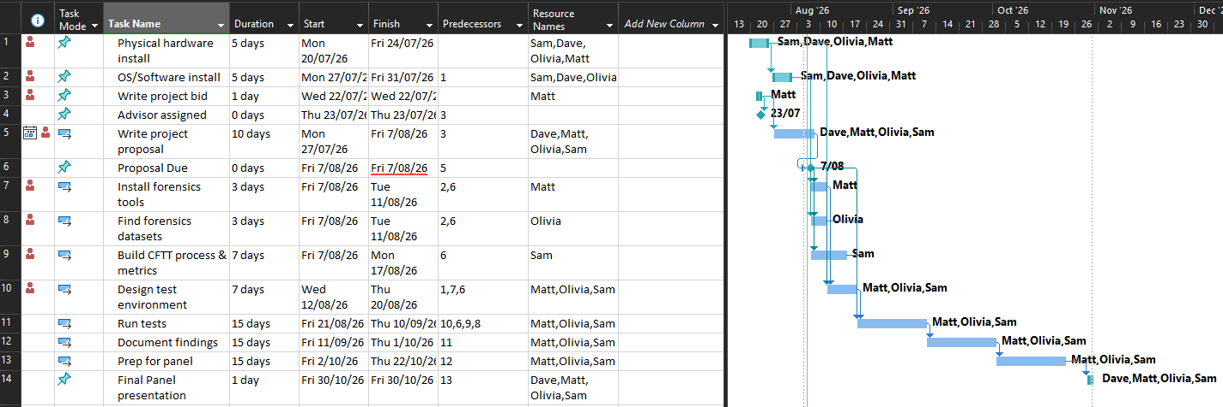

Appendix B
IT7510 Project Client Contract

WHITIREIA and WELTEC NEW ZEALAND
SCHOOL OF INNOVATION, DESIGN and TECHNOLOGY
PROJECT AGREEMENT

The Parties

This Student(s) Project Agreement (the “Agreement”) is made between:
- Whitireia and Weltec New Zealand School of Innovation, Design and Technology
(the “Faculty”);
- the nominated computing student(s) (the “Student(s)”) (as listed under section 6); and
Geoff Gordon the proposed Industry Organisation (the “Organisation”).

BACKGROUND

- As part of an established course of study at the Faculty, Bachelor of Information Technology students take a course module IT7x01, in which the Student(s) completes a project (“the Project”) with the Organisation on the basis set out in this Agreement.
- The Organisation agrees to allow the Student(s) access to its premises if needed to undertake that Project on the basis set out in this Agreement.
- The Faculty is satisfied that the Organisation is suitable for the Student(s) Project.

TERMS

1. Effective Date

This Agreement shall be effective as of ____________________ until ________________

2. Undertakings

2.1 The Organisation has accepted the Student(s) and agrees to allow that Student(s) access to its premises as needed.
2.2 The Organisation agrees to be responsible for meeting the requirements of its statutory obligations, e.g. Health and Safety in Employment Act, Human Rights Act, etc., for the Student(s).
2.3 The Student(s) will use their best efforts in undertaking the Project for the Organisation, as mutually agreed by the parties and set out in a separate written proposal which will form part of this Agreement.
2.4 The Organisation understands that the primary reason for the Project is education and advancement of knowledge, and, consequently, the Project must further that purpose.
2.5 Neither the Faculty nor the Student(s) guarantee specific results and the Project will be undertaken only on a best efforts basis.
2.6 The Student(s) agrees to submit their IT7510 report to their nominated supervisor at the Organisation.

3. Copyright, Patents, Trade Marks and other Intellectual Property Rights
The Faculty and Student(s) each acknowledge that all copyright, trademarks, trade names, patents and other intellectual property rights belonging to the Organisation that the Faculty and Student(s) come into contact with are and shall remain the sole property of the Organisation, and no claim or right to them is to be made by or created in the Faculty or Student(s).

4. Confidential Information
4.1 The parties may wish, from time to time, in connection with the Project undertaken under this Agreement, to disclose certain information of a confidential nature (“Confidential Information”) to each other. Each party will use reasonable efforts to prevent the disclosure of any of the other parties Confidential Information to third parties for a period of three (3) years from receipt of that information, provided that the recipient party’s obligation shall not apply to information that:
- is not disclosed in writing or reduced to writing and marked with an appropriate confidentiality legend or designated in writing as Confidential Information within thirty (30) days of disclosure;
- is already in the recipient party’s possession at the time of disclosure;
- is or later becomes part of the public domain through no fault of the recipient party;
- is received from a third party having no obligations of confidentiality to the disclosing party;
- is independently developed by the recipient party; or
- is required by law or regulation to be disclosed.
  - Application may be made to any party for written permission to use Confidential Information.
No party shall unreasonably withhold such permission.
  - If permission to use Confidential Information is withheld by a party, then that party will state the reason or basis for refusal of permission.

5. Intellectual Property Rights
5.1 The parties agree that both the Faculty and the Student(s) may use the intellectual property rights that are created as a result of the Project work undertaken by each Student for the Organisation for portfolio purposes to promote the Faculty and/or the Student(s).
5.2 The following intellectual property rights are agreed between the parties:
(Please indicate which option is agreed upon by placing a tick in the appropriate box and deleting the options that do not apply.)

Option 3 – Split Ownership
There shall be two types of intellectual property:
- Custom property (being intellectual property specifically developed by the Student(s) for the Organisation)
- Generic property (being any intellectual property not specifically developed by the Student(s) for the Organisation)
The Custom property will be vested solely in the Organisation whereas Generic property will vest solely in each respective Student. Each Student hereby grants the Organisation and where more than one Student has been involved in the Project, the other Student(s), a perpetual non-exclusive licence for that Generic property.

6. Signatures
Project Name: AI vs Legacy Digital Forensics Tools – A Comparative Efficacy Analysis
Table 8 - Project contract signatures
 | Role | Name | Signature | Date
Project Client  Organisation  Representative |  | Geoff Gordon
Representative of Whitireia New Zealand/ Faculty
Representative
Student | Project Manager | Dave Sushames
Student | Developer/Researcher/Tester | Matt Baker
Student | Developer/Researcher/Tester | Sam Davies
Student | Developer/Researcher/Tester | Olivia Hey

Appendix C
Geoff did not require an NDA to be signed.
Figure 3 - Confirmation of no NDA required
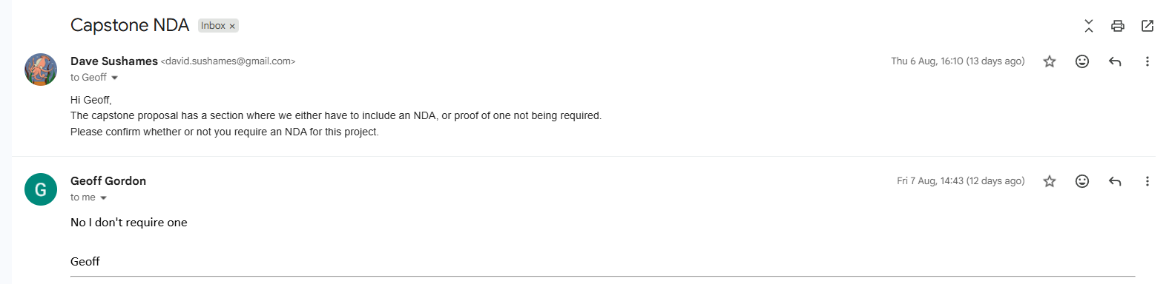

Appendix D
Week 3 Group Log:
Final project outcome
- Report isn’t enough
- Suggests we talk to Geoff about the final outcome and what he expects to get out of it
- Suggests we ask a lot of questions
- Research and create proposal to Geoff so we can discuss requirements
Research different project methodologies
- Dave make a Gantt chart on Microsoft project
- Gantt chart is a live document
- We should begin with a WBS and network (?) and then do the Gantt chart so it is optimized
- Is a dynamic document
Github isn’t exclusive to programming, can upload any files
- Research how to use github for storing our data and document changes
- How to use git for our proposal?
- Reiterates research
Dave needs to reply to emails
- Have a meeting with Geoff next week and draft 1 of proposal by Thursday 12 next week to go over with Clement next week
- Produce work output of hours you do
- Recommends AI to sort research topics
- Dave build an agenda for meetings and send the notes to Clement beforehand.
Ends at 2pm

